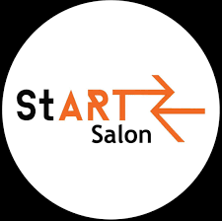**Truth North: Rising Together**

**StART Salon 8.0**

**Call for Artists**

**V3 1/19/2023**

March 23rd, 7-9 PM

Calling all PVA students for Start Salon 8.0, True North: Rising Together!

StART Salon is an annual event presenting music, theatre, dance, and visual arts in downtown Greeley. Curated and presented annually by UNC Performing Visual Arts College students.

**Mainstage Submission**

We are looking for proposals of artwork and performances that are a collaboration between two or more artistic disciplines inspired by one of the words on the list below. Get creative with how you collaborate!

If your proposal is chosen, you will be given a ten-minute time slot at the Moxi Theatre, so keep in mind the size limitations of the space.

You must be available the evening of March 22nd for a dress rehearsal, and before and during the entirety of the event on March 23rd to be considered.

Light

Future

Vulnerability

Empathy

Progress

Love

Compassion

Unity

**Submissions**

All proposals are due by midnight on February 8th. Proposals will be chosen, and artists notified of their acceptance by February 13th.

Completed proposal forms can be sent to [arts.entrepreneurship@unco.edu](mailto:arts.entrepreneurship@unco.edu). The form can be found here: 

We look forward to seeing what you create!

**Questions? Just Ask!**

Phoenix Thomas, Event Manager: [thom3847@bears.unco.edu](mailto:thom3847@bears.unco.edu)

Stephanie Hight, Music Coordinator: [high7060@bears.unco.edu](mailto:high7060@bears.unco.edu)

Lauren Kensley, Theatre and Dance Coordinator: [stuc6256@bears.unco.edu](mailto:stuc6256@bears.unco.edu)